Contact: Patrick Smith or Bet Zimmerman
860.974.3020 or 860.933.5713
contact@patrickmlsmith.com

PRESS RELEASE
LOCAL AUTHOR’S NON-FICTION BOOK PUBLISHED ON LOVE, LOSS AND GRATITUDE

Leaving the Life: A True Story of Love, Loss and Gratitude by local author Patrick McKenna Lynch Smith was recently published by Chimalis LLC. The book, which was three years in the making, is a brutally honest account of true love, loss and survival. Smith said, “I actually wrote the book to save my life. I hope it will move, touch and inspire others.”

Leaving the Life brings the reader inside private lives of an ordinary couple as their world is turned upside down by a shocking diagnosis. There is a surprise happy ending that not even the author knew was coming.

Their journey will leave you grateful for what you do have, and for what you do not have. You will also cling a little closer to the ones you love. Smith said “While, in the end, it was an honor and a privilege to have this experience, I hope to never have another one like it.”

The book is ideal for:
- Anyone who wants to see what it is really like when life as you know it unravels.
- The millions of people whose lives have been affected by serious illness, especially the caregivers.
- Anyone who has experienced loss, including widows and widowers in search of a story they can relate to.
- Friends and family trying to understand what caregivers and the bereft experience.
- Medical professionals, such as doctors, nurses, hospice workers, clergy, social workers and counselors.

The author’s website, with excerpts from Leaving the Life, is at www.patrickmlsmith.com. Leaving the Life is currently available on the author’s website and on Amazon.com as a paperback or eBook.

Mr. Smith is available for readings and local book signings with libraries, book clubs and other venues, and for interviews.

Like his wife Claudia Vincenti, Patrick Smith graduated from New Canaan High School. Claudia graduated from UCONN and worked at Logee’s Greenhouses and Crabtree & Evelyn. Patrick earned a degree in Anthropology from the University of Colorado. The couple owned a house in Killingly CT for 22 years before moving to Woodstock CT in 2007. The author graduated from the University of Colorado with a B.S. in Anthropology. In between writing, he has worked as a commercial fisherman and in the building trades.

Smith served as a guest lecturer at Laurelynn Martin's "Write Your Life" seminars, was selected for a scholarship for the prestigious Bread Loaf Writer's Conference, and has written copy for catalogs. He is currently working on a novel.

(NOTE: You do NOT need an Amazon Kindle to read Kindle eBooks. Amazon offers free apps that will let you read their eBooks on just about any computer, tablet, or smartphone.)

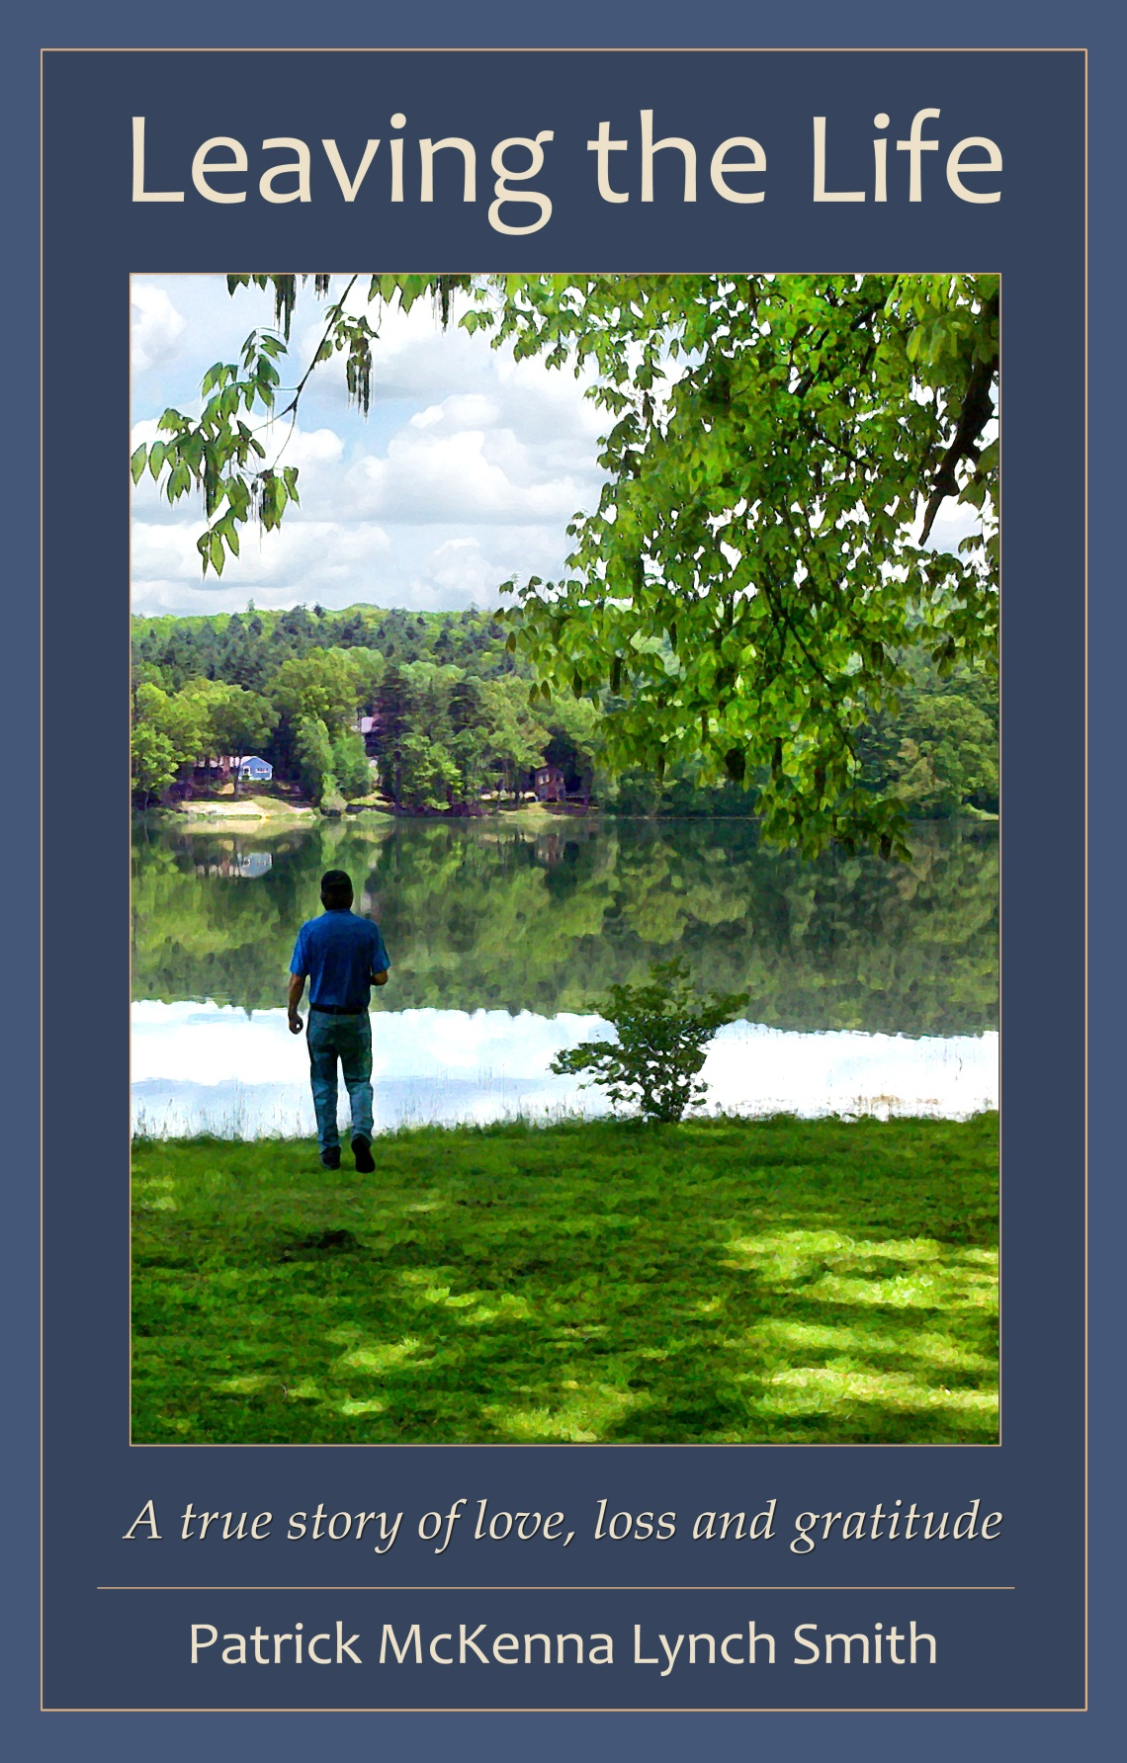

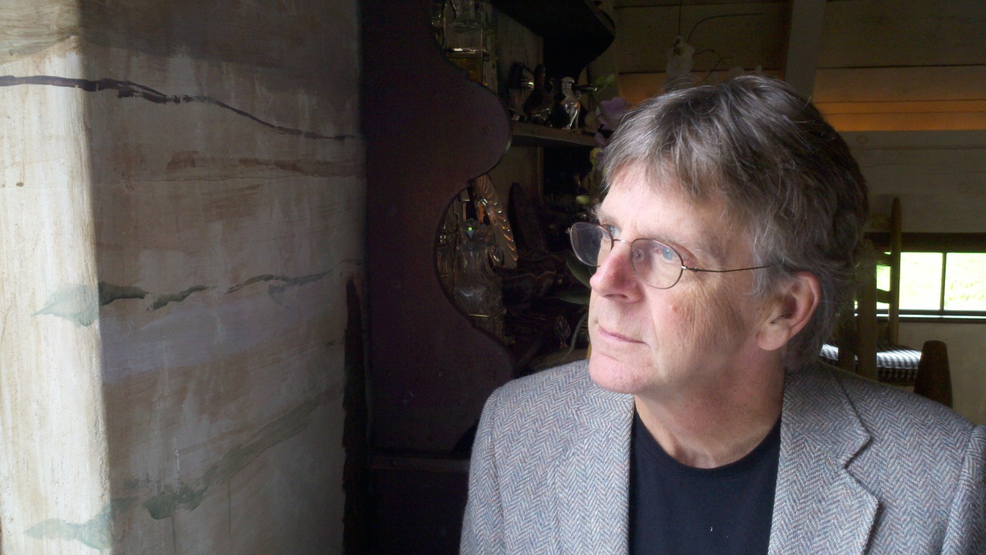

What readers are saying about Leaving the Life:
“It was heart wrenching, beautiful, inspiring and humbling. I marveled at your deep thoughtfulness and use of the English language.... It was a captivating, tragic story, yet you were able to connect with the reader in a deep, profound, life-affirming way...." ~ Laurelynn Martin, of Brooklyn, author of Searching for Home

"The book hooked me from the introduction…. It reads like a novel – and in some ways I wish it were fiction as then these events would not actually have happened...." ~ Beth Schwaner

"I couldn't put it down. I felt like I was watching a train wreck, and was emotionally drained at times, but I loved reading about your life together and how you handled the horror of it all." ~ Karen Chapuis of Woodstock

Brilliant! It read like a thriller. I was moved and inspired. ~ Reva Seybolt, Hands-on Healer of Woodstock

"I don't have words to express my gratitude, my awe, not only for what you have lived through, but the elegant humanity of your writing. You take us with you into the dark terror of a living hell…. I was moved to tears." ~ Lisa Davidson of Woodstock

“The best and most original book I’ve read in a long time.” ~ Larry E. Zimmerman, novelist, author of the Amston Lake mystery series

